VISION GUIDED GANTRY ROBOT SYSTEM A PROJECT REPORT
Submitted by

DHARSHAN S | (111719107008)
HANEY VMP | (111719107010)
VIGNESH E | (111719107042)

in partial fulfilment for the award of the degree
of

BACHELOR OF ENGINEERING
in

ELECTRONICS AND INSTRUMENTATION ENGINEERING




R.M.K. ENGINEERING COLLEGE
(An Autonomous Institution)
R.S.M Nagar, Kavaraipettai – 601206

ANNA UNIVERSITY : CHENNAI 600025
APRIL / MAY 2023

R.M.K. ENGINEERING COLLEGE
(An Autonomous Institution)
R.S.M Nagar, Kavaraipettai-601 206

BONAFIDE CERTIFICATE

Certified that this project report “VISION GUIDED GANTRY ROBOT SYSTEM” is the bonafide work of “DHARSHAN S (111719107008),HANEY VMP (111719107010), VIGNESH E (111719107042)” who carried out the project work under my supervision.

SIGNATURE  Dr. T. GNANASEKARAN, M.E., Ph.D., PROFESSOR & HOD | SIGNATURE  Ms. S. PRIYADHARSHINI ASSISTANTPROFESSSOR SUPERVISOR,
Department of Electronics and  Instrumentation Engineering, | Department of Electronics and  Instrumentation Engineering,
R.M.K. Engineering college,  R.S.M. Nagar, Kavaraipettai-601 206 | R.M.K. Engineering College  R.S.M. Nagar, Kavaraipettai-601 206.

R.M.K. ENGINEERING COLLEGE
(An Autonomous Institution)
R.S.M Nagar, Kavaraipettai-601 206

BONAFIDE CERTIFICATE

The report of the project work “VISION GUIDED GANTRY ROBOT SYSTEM” is the bonafide work of “DHARSHAN S (111719107008), HANEY VMP (111719107010), VIGNESH E (111718107017)” in partial fulfilment for the award of Bachelor of Engineering degree in Electronics &Instrumentation Engineering of Anna University was confirmed to be the report of the work done by the above students and then evaluated.

Submitted for the Project Viva-Voce held on……………………………………. at R.M.K. Engineering College, Kavaraipettai, Tiruvallur - 601 206

SIGNATURE SIGNATURE
INTERNAL EXAMINER EXTERNAL EXAMINER

ACKNOWLEDGEMENT

First, we thank the almighty and our parents for their blessings and moral support throughout our life and also making this project a successful one.
At the outset, we would like to express our gratitude to our beloved and respected Chairman, Thiru. R. S. MUNIRATHINAM for his support and blessings to accomplish the project. We would like to express our thanks to our ViceChairman, Thiru. R. M. KISHORE for his encouragement and guidance.
We express our sincere thanks to our Principal, Dr. K.A. MOHAMED JUNAID, M.E., Ph.D. for rendering us all facilities for undertaking the project.
It is an immense pleasure for us to express our gratitude and heartfelt thanks to Dr. T. GNANASEKARAN, M.E., Ph.D., Head of the Department and our supervisor Mrs. S. PRIYADHARSHINI, Assistant Professor for valuable inputs and ideas during the course of our project.
Our thanks to all faculty and non-teaching staff members of our department for their constant support to complete this project.

ABSTARCT

This project is about creating a dynamic, user-friendly inventory management website for tracking and controlling items within a manufacturing setup. Constructed using current web technologies and integrated with Firebase services, the system provides real-time management of items using a centralized database. It allows users to securely log in, post new items, modify existing records, remove old records, and export inventory details in PDF format. All items contain extensive metadata like part number, quantity, description, location, and an image uploaded to cloud storage directly. For better usability and searchability, the system includes a tag-based filtering system and responsive search bar to enable users to easily find particular items or categories. The use of light/dark themes ensures visual comfort, while Firebase Authentication guarantees session security and access control. The ease-of-use layout and responsive design guarantee that the platform is accessible on any device, including mobile and desktop users. This solution is perfect for companies that want to modernize their inventory tracking process, eliminate human errors, and increase operational efficiency. With the possibility of future scalability—such as building analytics or predictive restocking through machine learning—the inventory management system provides a strong base for intelligent inventory practices in industrial environments.

TABLE OF CONTENTS

CHAPTER | TITLE | PAGE  NO
ABSTRACT
TABLE OF FIGURES
LIST OF ABBREVIATIONS
1 | INTRODUCTION  - SYSTEM ANALYSIS | 1
2 | LITERARY SURVEY | 2
3 | - EXISTING WORK  - PROPOSED WORK | 4  4
4 | HARDWARE SPECIFICATIONS  - ELECTRICAL COMPONENTS  - CONTACTOR  - 3-POLE MCB  - 2-POLE MCB  - 8-CHANNEL RELAY BOARD  - SMPS  - SERVO DRIVE  - CTRL X PLC  - PLC INPUT AND OUTPUT MODULE  - FUSE TERMINAL BLOCK AND TERMINAL BLOCK  4.1.10.VISION CAMERA
5
7
8
10
11
13
14

16

17
19

 | 4.2. MECHANICAL COMPONENTS
 | 4.2.1. SERVO MOTOR | 21
 | 4.2.2. SOLENOID VALVE | 22
 | 4.2.3. PNEUMATIC GRIPPER | 23
 | 4.2.4. FLOW REGULATION VALVE | 25
 | 4.2.5. REED SWITCH | 26
 | 4.2.6. LIMIT SWITCH | 28
 | 4.2.7. PNEUMATIC CYLINDER | 29
 | 4.2.8. SERVO MOTOR GEAR | 31
 | 4.2.9. LINEAR MOTION GUIDE
 | RAIL | 32
 | 4.2.10. RACK AND PINION | 33
 | 4.2.11. BALL SCREW ROD | 34
5 | WIRING DETAILS
 | 5.1. AC SECTION | 36
 | 5.2. NEUTRAL SECTION | 36
 | 5.3. DC SECTION | 36
 | 5.4. PLC SECTION | 37
 | 5.5. DIRECT ON LINE STARTER | 37
 | 5.6. HMI CONNECTION | 37
 | 5.7. CIRCUIT DIAGRAM | 38
6 | METHODOLOGY  6.1. WORK FLOW MODEL
 |  | 40
7 | WORKING | 41
8 | RESULT AND OUTPUT | 44
9 | CONCLUSION | 48
 | 9.1. FUTURE SCOPE | 49
 | 9.2. REFERENCE | 50

TABLE OF FIGURES

FIGURE NO | TITLE | PAGE NO
1 | CONTACTOR (18 AMPS) | 5
2 | 3-POLE MCB (16 AMPS) | 7
3 | 2-POLE MCB (18 AMPS) | 9
4 | 8-CHANNEL RELAY BOARD | 10
5 | SMPS (10 AMPS) | 12
6 | SERVO DRIVE | 13
7 | CTRL X PLC | 15
8 | PLC INPUT AND OUTPUT MODULE | 16
9 | FUSE TERMINAL BLOCK AND  TERMINAL BLOCK | 18
10 | VISION CAMERA | 19
11 | SERVO MOTOR | 21
12 | SOLENOID VALVE | 22
13 | PNEUMATIC GRIPPER | 24
14 | FLOW REGULATOR VALVE | 25
15 | REED SWITCH | 27
16 | LIMIT SWITCH | 28
17 | PNEUMATIC CYLINDER | 30
18 | SERVO MOTOR GEAR BOX | 31
19 | LINEAR MOTION GUIDE RAIL | 32
20 | RACK AND PINION | 34
21 | BALL SCREW ROD | 35
22 | CIRCUIT DIAGRAM-1 | 38
23 | CIRCUIT DIAGRAM -2 | 39
24 | METHODOLOGY | 40

25 | OVERALL ASSEMBLY OF  GANTRY SYSTEM | 43
26 | TO THE FIRST PICK UP  POSITION | 44
27 | MOVEMENT OF THE GANRTY | 45
28 | PLACING OF SECOND TARGET | 46
29 | MACHINE AT REST | 47

LIST OF ABBREVATION

- MCB – MINEATURE CIRCUIT BREAKER
- SMPS – SWITCHED MODE POWER SUPPLY
- PLC – PROGRAMMABLE LOGIC CONTROLLER
- CTRL X – CONTROL X
- DOL – DIRECT ON LINE STARTER
- HMI – HUMAN MACHINE INTERFACE

CHAPTER 1
INTRODUCTION

  - SYSTEM ANALYSIS
The Inventory Management Website is a web-based, centralized site aimed at simplifying the storage, retrieval, and tracking of products in an industrial environment. The conventional way of handling inventory using spreadsheets or hand records consumes time, is subject to human mistakes, and does not reflect real-time updates. This project solves these issues by utilizing a digital platform that draws on Firebase services, offering real-time synchronization, secure access management, and expandable data storage. The system supports adding, editing, and deleting inventory items with fields like item name, part number, quantity, description, location, and tags. Using a tidy, responsive user interface, users can engage with the system on various devices, from desktops and laptops to tablets. With Firebase Authentication, only authorized staff members can access and edit inventory information, offering a safe and trustworthy setting. For better visibility and convenience, the system has a tag-based filtering system and an intelligent search bar, providing easy access to certain items or categories. PDF export capability has the facility for users to create extensive or low-stock reports at the click of a button, facilitating restocking decisions and documentation. Compared to third-party or conventional inventory software, this bespoke system is light, affordable, and specialized in the particular needs of warehousing and manufacturing operations. It enhances speed, accuracy, and usability while substantially lowering reliance on manual processes. By adopting this system, industries can look forward to enhanced resource planning, less downtime from stockouts, and enhanced traceability of materials. The architecture is modular and can accommodate future incorporation of sophisticated features like inventory analytics, threshold-based notification, and predictive stock management through machine learning.

  - PROBLEM STATEMENT

Inventory management is a fundamental process in manufacturing and service sectors that ensures materials and products are efficiently tracked, stored, and utilized. Yet in most small and medium-scale businesses, inventory continues to be monitored on manual logs, spreadsheets, or old desktop-based applications. These processes are not only time-consuming but also susceptible to data loss, duplication, and human error. Manual systems do not have real-time updates, centralized access, and tend to bring about inconsistencies in stock levels, delayed decision-making, and miscommunication among departments. As business grows, handling inventory manually becomes more difficult and time-consuming. Workers can spend much of their time searching for product information through various files, forgetting to record changes in the stock, or dealing with conflicts in versions when two or more individuals are working on the same data. Additionally, there is limited or no support for authentication of users, making the information accessible or editable without any control, creating issues of security. Current inventory software solutions are mostly costly, complicated, or non-customizable for targeted industrial requirements. They lack core features like cloud storage, mobile access, image support, or connectivity to analytics for stock-level tracking. In a manufacturing setup, where accuracy and real-time information are a must, such shortcomings can affect manufacturing timelines, customer happiness, and efficiency of operations. Thus, there is an evident requirement for a secure, affordable, and scalable web-based inventory management system that can resolve these issues. The system proposed here seeks to combine cloud computing, security login mechanisms, and sophisticated filtering tools to present an innovative solution applicable to the needs of industries. Through functionalities such as real-time updations of items, tag search, low-stock notifications, and PDF export functionality, the system will provide greater accuracy, speed, and control over inventory management. This will ultimately lead to enhanced productivity, improved decision-making, and minimized operating downtime in manufacturing and warehouse settings.

1.3 OBJECTIVE
The main goal of this project is to create and implement a web-based Inventory Management System that will allow industries, particularly in manufacturing and warehouses, to effectively manage and track their inventory in real-time. The aim is to substitute obsolete manual processes with a digital, centralized system that is accessible and user-friendly. The system has the objective of enabling users to safely add, modify, remove, and see inventory information using an easy-to-use interface. With real-time synchronization based on Firebase Firestore, all the changes that users input are automatically synced across all devices, providing consistency and the latest information at any moment. In order to make items more searchable and categorizable, the system incorporates a tag-based filtering system and a clever search bar, which provides rapid access to particular items or categories. Firebase Authentication is implemented to handle secure user log-in and session management, guaranteeing that only approved users are able to access the system. The site also offers the export functionality for inventory data in the form of PDF files, comprising complete inventory listings and low-stock items reports, which aid in stock planning and documentation.Both light and dark modes are supported by the interface to meet user preferences and enhance readability under varying working conditions. The design is generally responsive, so it can be used easily on desktops, laptops, and tablets. By adopting this system, industries are able to minimize human mistakes, enhance the accuracy of inventory, enhance speed of operations, and gain more control over inventory management. This project is a cost-efficient and scalable solution for supporting increasing inventory requirements in a secure and efficient manner.

1.4 SCOPE OF THE PROJECT

The aim of this project is focused on creating a web-based inventory control system with real-time monitoring and control of the stock level for industries based on manufacturing or warehouse. The system is platform-independent so that users can access it on any device with a current web browser and internet connection. This project entails the execution of fundamental inventory operations like adding, updating, deleting, and displaying item information. Every item may be assigned critical metadata such as part number, item name, quantity, description, location, and user-specified tags for categorization. The tagging system improves filtering and searchability, allowing users to easily find specific items\\ or collections of items. For data security and controlled access, the system utilizes Firebase Authentication, which handles user login and session validation. Authenticated users are the only ones allowed access and manipulation of inventory data, thus preventing unauthorized alterations. Real-time updates via Firebase Firestore ensure that all data changes are updated immediately on all devices and users. The system also allows data export in PDF form for the entire inventory or low-stock products so companies can keep records and schedule reorders efficiently. An option to toggle between dark and light theme has been added to provide improved user experience under varying working conditions, particularly in manufacturing setups. Although the latest iteration targets basic functionalities, the project is scalable. Potential future additions can include functions like inventory analysis, reorder notifications, user roles with permission management, and integration with mobile devices or barcode scanning systems. In general, the scope of the project includes the development of a safe, effective, and easy-to-use inventory management web application designed to address the operational requirements of small to medium-sized industrial companies looking to automate and modernize their inventory systems.

1.5 METHODOLOGY

The creation of the Inventory Management Website is a systematic and modular approach to guarantee a defined sequence from requirement gathering until deployment. The process starts with detailed requirement analysis, where the shortcomings of manual inventory systems in place and the requirements of industries—like real-time access to data, user-friendliness, and data protection—are thoroughly researched. Therefore, on the basis of this, the fundamental functionalities like item addition, deletion, modification, tag-based filtering, PDF export, and secure authentication are determined. After finalizing the requirements, suitable technologies are chosen. For frontend development, HTML, CSS, and JavaScript are utilized to provide responsiveness and cross-device support. Firebase is used as the backend platform because of its powerful real-time database (Firestore), built-in authentication system, and cloud features. The system is structured with a layered design pattern, wherein the frontend is responsible for handling user interaction, the backend is responsible for data operations, and an export layer facilitates generation of inventory reports in PDF format. Implementation phase includes incremental build of every core feature. Firebase Authentication is implemented to ensure that only valid users can read and write data. Firestore is employed to maintain inventory records in an organized format for real-time updates. A dynamic user interface is constructed to facilitate item management with fields such as name, quantity, part number, description, and tag. Usability features like smart search, filtering by tags, and theme switching (light/dark mode) are included to improve usability. The export feature is developed with JavaScript libraries to transfer inventory data in the form of downloadable PDF files. Once developed, the system is thoroughly tested to ensure functionality, performance, and security. Each module is tested against expected behavior, including successful login, correct item updates, filter correctness, and data integrity. The website is then made ready for deployment with appropriate hosting services and is rendered accessible to end-users via typical web browsers. The entire methodology guarantees that the system is stable, effective, user-friendly, and manageable for future improvements.

1.6 REPORT STRUCTURE

The report is divided into six chapters, with each chapter discussing a particular detail of the Inventory Management Website project. Chapter 1 gives an overview of the project, encompassing system analysis, problem statement, objectives, scope, methodology, and report structure overview. It establishes the context by describing the necessity for an effective, web-based inventory management in industrial settings.

Chapter 2 is a survey of literature on current systems and manual procedures. It points out the limitations of conventional inventory control techniques and discusses current electronic solutions, recognizing gaps to be addressed by the proposed system. This chapter also highlights related technologies and tools utilized in contemporary inventory systems.

Chapter 3 discusses the system design, i.e., architectural structure, module description, database structure with Firebase Firestore, and the user interface design. It describes how the components of the system interact and the logic behind some features such as tag-based searching, authentication, and theme switching.

Chapter 4 is about the system implementation, including the technologies employed, Firebase services integration, and core functionality development like real-time inventory updates, PDF export, and session control for users. It states how every feature was implemented practically and incorporated into a unified system.

Chapter 5 addresses the outcome and results of the project. It analyzes system performance, ease of use, and contrasts the new system with conventional practices. The advantages, efficiency gains, and challenges faced while developing are also examined.

Chapter 6 concludes the report by providing an overview of the accomplishments of the project and detailing potential future developments. This can include additions such as analytics, low-stock warnings, or integration with a mobile app to further enhance inventory management functionality.

CHAPTER 2
LITERATURE SURVEY / EXISTING SYSTEM
2.1 Manual Inventory Systems
Manual inventory systems have traditionally served as the core stock management in most small and medium-sized businesses. These systems usually consist of keeping manual logbooks, registers, or basic input forms for tracking item information, stock quantities, and movements. Although initially economical and convenient, these procedures grow more inefficient when the business expands. They are extremely susceptible to human error, such as data omission, duplication, and inaccuracies. Further, no standard format exists, which hinders auditing or tracking over a period of time. No real-time updates mean it may take longer to make procurement decisions, result in mismatches of stock, and lead to production delays. Physical records are also prone to damage or loss, and it takes time and effort to find something among many pages. In today's manufacturing operations that require speed and accuracy, these systems do not satisfy operational requirements.
2.2 Existing Digital Solutions
To overcome the shortcomings of manual and spreadsheet-based systems, many businesses have turned to digital inventory management systems. These systems range from self-contained desktop software that can control inventory systems to more complex enterprise resource planning (ERP) systems that include modules for procurement, warehousing, logistics, and stock control. Examples of systems include Zoho Inventory, Oracle NetSuite, and SAP Inventory Management, and sometimes a customized solution that is in-house. These digital systems offer most, if not all, the elements of automation; for example, with inventory control there are barcode scanning, stock alerts, reporting dashboards, vendor integrations, and so on. Cloud-based inventory systems have gained traction due in part to their accessibility and scalability, ease of collaboration with multiple users on real-time data, and the inability to "lose" your data due to hardware failure. Inventory systems that are cloud-hosted allow updates and access from multiple user endpoints. Cloud-based inventory systems are advantageous for businesses that have operations that are decentralized and have stock and inventory that must move frequently in large quantities to multiple places. Many of these systems are literally cutting-edge but most inventory systems and ERP systems are designed for enterprise or advanced use cases and as a result, many of them charge exorbitant license fees; as well as vendors might be able to charge for price for long term contract usage.

2.3 Limitations of Current Systems
Current systems, whether manual or including standard digital platforms, are quite limited and as such, reduce their usability within small manufactural settings in one way or another. Manual methods are certainly tedious and error-prone while spreadsheet-based solutions are a minor improvement because they cannot scale nor allow multi-user, real-time updates. There are also concerns regarding data duplication issues, version conflicts, and a general lack of automation. Most commercial applications allow for scaling but require costly implementation (both in terms of config, setup and use), require knowledge of specific technical skill sets. Many commercial applications are not suited for manufactural applications that use standard workflows. This means using a solution is difficult even if you get a comprehensive point. All we need is the ability to track items, monitor their inventory levels, and obtain basic operational insights. Additionally, some systems simply do not provide the type of offline-first usage or lightweight-deployment-and-integration modes with light-weight cloud services such as Firebase. Moreover, many users are expecting responsive user-interfaces that are simple in mobility, few commercial applications even bother making it a priority. All of these observed gaps indicate the necessity for a solution or service that provides small-to-medium enterprises (SMEs) with a useable, cost-effective and adaptable simplification on a cloud-based service for their manufacturing unit.
2.4 Summary of the Findings
The literature and systems evaluation in this chapter demonstrate that while there are numerous inventory management systems available, none meet the specific needs of small and mid-sized industries that desire a secure, scalable, and easy-to-use solution. The risks and inefficiencies associated with manual approaches have rendered them outdated. Spreadsheet techniques have slightly improved on manual approaches, but they remain limited. Additionally, spreadsheet approaches do not support multi-users, do not allow a live update of stock levels, and do not automate tasks. At the same time, existing commercially available digital solutions are inaccessible to smaller organisations. They are expensive, complex, and have rigid workflows and user interfaces. The results clearly indicate that there is an need for a web-based inventory management solution that provides basic, necessary features such as secure login, live item tracking, item search, basic reporting, and cloud synchronised data with minimal features and cost as compared to enterprise-grade systems. The Inventory Management Website is intended to fill the gap by providing a diminished, responsive, firebase backend system with affordability, intuitive purpose and intent. It is built using up-to-date web development technologies that ensure functionality and scalability for industries. wanting to move from outdated methods to an efficient digital inventory system.
CHAPTER 3: SYSTEM DESIGN

The Inventory Management Website was produced using an iterative approach to improving features and design by adding functionality incrementally. This approach allowed us to test and improve each version of the system concerning its functionality, usability, and performance in real time. In total, the website experienced three major iterations, ranging from a basic inventory viewer to an inventory management tool with secure login, tag-based filtering, PDF export, and real-time updates. The website was designed to modularize, scale, and simulate industrial inventory workflows.
3.1 System Architecture
The system architecture is structured following a client-server model, where the client only requires a web browser for access, and the Firebase services for the back end. The website is constructed with HTML, CSS, and JavaScript. The website enables the interaction of the front end with the back end. The website uses Firebase Authentication for handling user login and session maintenance to keep users logged in. The website uses Firestore (a NoSQL cloud database) to store the inventory information, including item names, item part numbers, item quantities, item descriptions, item sizes, and item tags. Whenever the user adds or updates an item, it will trigger the website code to call the Firestore API, which will then store and update the information in Firestore immediately. This means that all connected devices of the same the user will automatically see updates in real time. The website is programmed to let users search, filter, and create PDF documents based on the logic of the JavaScript libraries. With this system architecture, the process is simple, effective, and extraordinarily powerful, allowing the user to do all this with a very lightweight website and superb performance and handling of user data securely.
3.2 Module Description
The system is comprised of several modules that all work as inter-connected modules and have specific functions. The first module, the 'login', uses Firebase Authentication to securely verify the user credentials, and then directs them to the main dashboard, which displays an up-to-date inventory list. Users can enter new items into inventory through a form that requests item specifics such as, name, quantity, part number, and location. The update module, allows users to edit existing items by showing the current value, and editable value beside one another. This allows a user to understand if they want to simply overwrite the current value, or edit the current value. The user can also export the inventory list to PDF; if desired, may export an entire list, the lower, or just the ones they currently have assigned. The user can also switch themes from dark to light mode; and logout if they choose to. The modules work together as an interconnected system to provide a seamless user experience.
3.3 Database Design (Firestore Structure)
The Google Firebase system is utilizing Firestore as its database solution as it provides for real-time synchronization of data with its document-based storage. Each inventory item is treated as a document, which is contained in the inventoryItems collection. In each inventory item document, there are fields for item name, part number, quantity, description, size, location, and an array containing tags. Also included is a timestamp so sort the items and also to provide a log. Because Firestore follows a NoSQL document data structure, it can offer extremely fast read and write operations without following a tabular structure like fixed relational databases require. This design makes the system very responsive and straightforward to scale as the number of items increases. The array field for tags enhances the search and filtering functionality, allowing users greater flexibility in categorizing inventory items and retrieving them. Additionally, because Firestore provides real-time listeners, any changes that are made to the inventory - like adding new items or changing existing items - will be instantly reflected on the user's screen without the need for refresh.
3.4 User Interface Design
The interface for the website includes three main iterations in its design. In the first iteration, the only inventory list existed, and I made a simple form view to add items to the inventory. The layout was a prototype, minimal with no theme switches or advanced filter selections. At this point, I spent most of my time working on the backend and CRUD features. In the second iteration, the interface we created had all necessary fields in the form(s) i.e., size, description, tags, and we had published an update item page which brought in a two-panel layout. One panel for details of the current item, and one for making changes in the edit panel. The third and final iteration of the design was focused on enhancing usability and aesthetics. A responsive top bar was introduced with a clearly visible 'Add Item' button, dark/light mode toggle, and logout user session button. I built out the tag-based filtering as clickable pill objects, giving users the opportunity to filter item category in real-time. I also added in a search bar to provide users dynamic filtering as they typed. Through iterations with the above adjustments, they collectively provided for a more user friendly, intuitive and responsive web design.

First Iteration – Image Upload and Preview Issue
Fig 3.1

Fig 3.2

In version 1 of the inventory management website, an image upload function was developed to allow users to upload item images as they add or update items. As can be seen in Fig 3.1, the selected image was uploaded successfully, and the image was located in Firebase Storage URL successfully. However, in Fig 3.2, it was identified that the image was not rendered in the inventory list page. The URL for the image was stored correctly, but the image was not being fetched on the frontend or rendered for some of the following potential reasons including incorrect binding within the code, potential permissions error restrictions, or missing logic within the image preview handling. The issue affected the user experience and created inconsistency for how items were displayed. The image upload feature was removed from the system during this iteration to allow us to focus on stabilizing the core inventory processes in this iteration.

Second Iteration – Theme Toggle, Logout & Low Stock Feature

Fig 3.3
In the second update to the inventory management website, further usability and functional options were added that seek to promote user experience and inventory tracking capabilities. This included, as part of this update, a theme toggle switch in the sidebar of the website that allows users to switch between light and dark themes, thereby allowing for maximum convenience and comfort during extended periods of use. Users can now also fast-track their logout process through the new sidebar logout button, resulting in a secure seamless ending to their session with only one click! Users will now arrived at the log-in screen. An opportunity was also taken to add a new a Low Stock feature--a button that filters the inventory items that only display items with a quantity of less than 10. This feature permits for real time visibility between a critical stock loss and the users ability to act to replace the lost stock in a timely manner. These additions are seen as improvements towards making this system more user friendly and practical, useful and functional.

Third Iteration – Export Feature, Navigation, and UI Alignment
Fig 3.4
In the third update (Fig. 3.4), more functionality was introduced, specifically around usability (and simplifications). One of the key improvements was the new Export PDF capability. You can export your inventory list as either the Full Inventory List or just the Low Stock items (which is any item that has a quantity less than 10, and is useful for use in inventory and reporting). The navigation was improved by incorporating a “Back to Inventory” button on the Add Item and Update Item pages, which improves flows in navigating between screens. In addition, the three primary buttons for Add Item, Low Stock, and Export List were moved into the top right corner of the inventory page, and appropriately aligned for better accessibility and visual flow. These additions and improvements contribute to a more refined inventory management experience.

Fourth Iteration – Dynamic Low Stock View & Tag-Based Search

Fig 3.5

Fig 3.6
During the fourth iteration (See Fig. 3.5 & Fig. 3.6), significant upgrades were made to improve the dynamic and organized aspects of inventory tracking for each user. In the Low Stock feature, once clicked, items with a quantity less than 10 were filtered and displayed immediately, rather than just highlighting it in the previous iteration. In addition to signifying research restock items that were needed, it provided a direct view of the inventory that needed restocked. Another upgrade consisted of a tagging system, whereby each item could be associated with one or more tags (i.e., #bosch). Once tagged, users would be able to search using the inventory search bar, and the system would find and filter every item relating to a tag. Each update noticeably improved the classification and searchability of inventory, making the system more scalable, and intuitive for users operating with a vast number of components.

3.5 Security and Authentication Design

To facilitate secure access and data protection, this system integrates Firebase Authentication, which provides the necessary tools for managing login state and session state, as well as allows anyone logged in to view the inventory dashboard. Read, write, etc. will not be available to logged in or registered users. If an unauthenticated user attempts to access any pages protected by authentication they will be given an error and redirected automatically. This is all to make sure that the restricted inventory data not be given to unregistered users. In all of this, Firestore has additional security rules that only allow clients to perform database actions like read and write on its database to authenticated users. This mitigates the risk that a user gets their data via other harm given access. Although the authentication we implemented is rudimentary, email/password-based, and probably not sufficient for robust enterprise applications, it's perfectly fine for small to mid-sized industrial applications. Also, if we want to expand later on, we could do this by implementing role-based access or allowing multi-user access or something similar.

3.6 Workflow Diagram

voltage and current to drive the motor, while the amplifier amplifies the control signals from the controller to the appropriate levels required by the motor.

The control circuit receives the control signals from the controller and adjusts the amplifier's output signals to control the motor's position, speed, and torque. The feedback circuit monitors the motor's actual position, speed, and torque and provides feedback signals to the control circuit to ensure that the motor is performing as desired.

In summary, servo drives play a critical role in industrial automation applications where precision control of motor position, speed, and torque is required. They are essential components that provide the interface between the control system and the motor, ensuring that the motor performs as desired to achieve the desired automation outcome.

CTRL X PLC

Ctrl x PLC is a new generation programmable logic controller (PLC) developed by Bosch Rexroth, a global engineering and technology company. It is a revolutionary PLC system that combines the flexibility of a PC-based control system with the robustness and reliability of a traditional PLC.

Ctrl x PLC is based on an open architecture that allows for the use of standard programming languages like C++ and Python, making it easy for programmers to develop applications and customize the system to meet specific needs. The

system is highly scalable and can be easily expanded by adding additional hardware modules or software functions.

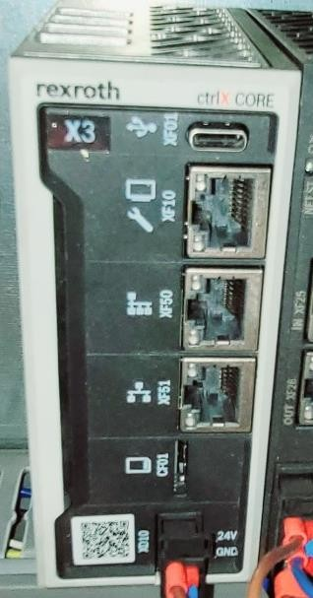

Figure 7. CTRL X PLC

This makes it a suitable choice for a wide range of applications, from small machines to complex production lines.
Ctrl x PLC offers high performance and speed, with a response time of just 1 nanosecond. It also supports multi-core processors, which enables it to handle complex processes with ease. The system offers a wide range of connectivity options, including Ethernet, CAN, Profibus, and Profinet. This makes it easy to integrate with other systems and devices, such as sensors, HMIs, and robots.
Ctrl x PLC features a user-friendly interface that makes it easy for operators and technicians to monitor and control processes. The system also supports remote access, allowing users to monitor and control processes from anywhere in the world.

PLC INPUT AND OUTPUT MODULE

PLC (Programmable Logic Controller) Input and Output modules are essential components of a PLC system. The PLC input module is responsible for reading data from various sensors, switches, and other devices, while the output module is responsible for sending control signals to actuators, motors, and other devices.

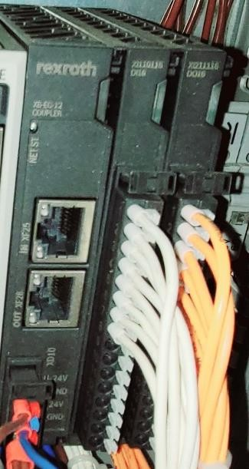
Figure 8. PLC Input and Output Module

Input Module:

The input module consists of multiple channels, and each channel can be used to read signals from various types of input devices. These input devices can include digital sensors (e.g., limit switches, proximity sensors) and analog sensors (e.g., temperature sensors, pressure sensors). The input module typically contains a signal conditioning circuitry that amplifies or filters the input signal, and then converts it into a digital signal that can be processed by the PLC. The input

module communicates with the PLC's central processing unit (CPU) over a backplane bus or network.

Output Module:

The output module is responsible for sending control signals to various types of output devices. These output devices can include digital actuators (e.g., solenoid valves, relays) and analog actuators (e.g., motors, variable frequency drives). The output module typically contains circuitry that receives the control signal from the PLC's CPU and amplifies or filters it to provide the necessary voltage or current to drive the output device. The output module communicates with the CPU over the backplane bus or network.

Both input and output modules are available in different configurations, including various numbers of channels, different types of input or output signals, and different voltage or current ratings. Some PLC systems also include combination input/output modules that can perform both functions within a single module.

FUSE TERMINAL BLOCK AND TERMINAL BLOCK

A terminal block is an electrical connector that allows multiple wires to be connected to a single connection point. It consists of a molded plastic or metal housing with multiple screw-type terminals that allow wires to be clamped into place. Terminal blocks are commonly used in electrical equipment, control panels, and automation systems to simplify wiring and facilitate maintenance.

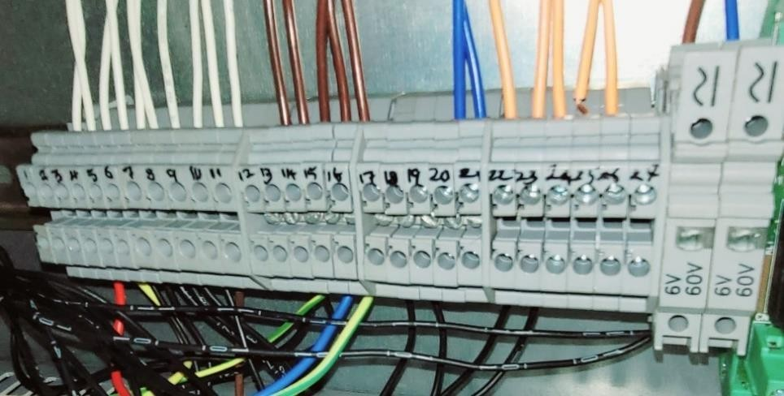
Figure 9. Fuse Terminal Block and Terminal Block

A fuse terminal block is a type of terminal block that includes a built-in fuse holder. It allows a fuse to be inserted into the terminal block, providing protection against overcurrent conditions that could damage the connected equipment. The fuse terminal block typically consists of a plastic or metal housing, screw-type terminals, and a fuse holder.

Fuse terminal blocks are commonly used in applications where electrical equipment needs to be protected against overcurrent, such as in power supplies, motor control circuits, and lighting systems. They are available in various sizes and current ratings, and can accommodate different types of fuses, including blade fuses, glass fuses, and ceramic fuses.

The built-in fuse holder provides protection against overcurrent conditions, preventing damage to the connected equipment. By combining the functions of a terminal block and a fuse holder, a fuse terminal block can save space and reduce the complexity of a wiring system. Fuse terminal blocks can accommodate different types of fuses and are available in different sizes and current ratings to suit a variety of applications.

VISION CAMERA

The vision camera serves as the "eyes" of the gantry robot, allowing it to perceive the environment and make decisions based on visual information. This is particularly useful in applications that require high precision and accuracy, such as pick-and-place operations in manufacturing and assembly. The camera can detect and identify objects, measure their dimensions and position, and guide the gantry robot to perform the necessary actions.

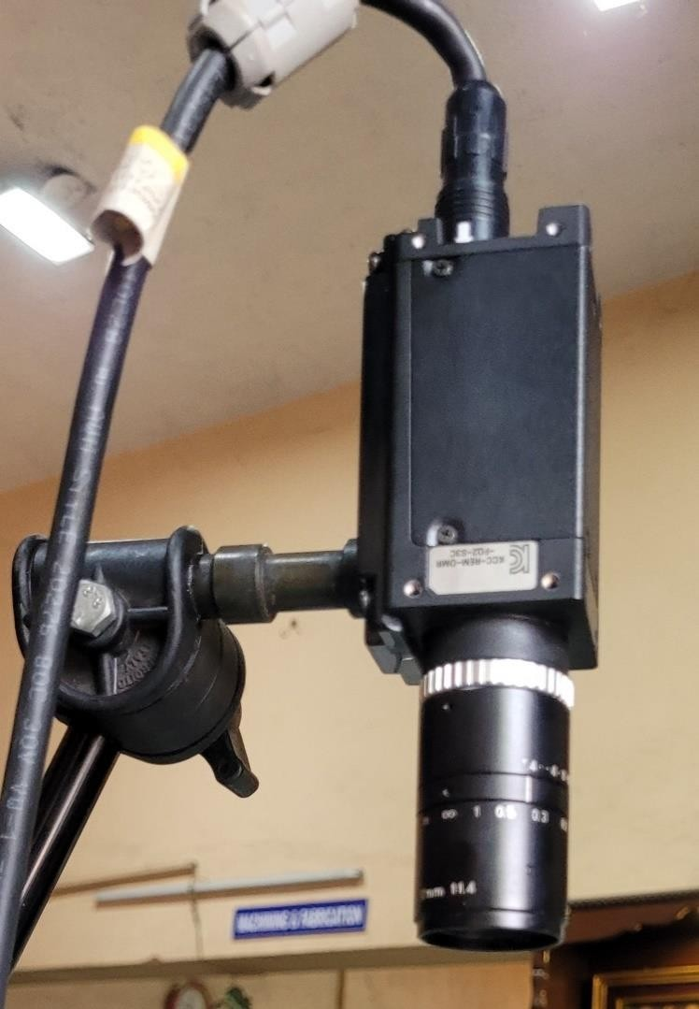

Figure 10. Vision Camera

Omron FQ2 vision cameras are advanced imaging devices that are commonly used in industrial automation applications. They are highly versatile and capable

of performing a range of tasks, including object recognition, measurement, and quality inspection. These cameras use advanced image processing algorithms to analyze visual data and provide accurate and reliable results.

One of the key features of the Omron FQ2 vision camera is its high-speed image processing capabilities. The camera can capture and process images at high speeds, allowing for rapid and efficient inspection and measurement of objects. This is particularly useful in applications where speed is critical, such as high- speed production lines.

Another advantage of the Omron FQ2 vision camera is its flexibility. The camera can be easily programmed to perform a wide range of tasks, and it is compatible with a variety of communication protocols, including Ethernet and RS-232. This makes it easy to integrate with existing industrial automation systems, and it allows for seamless communication with other devices and machines.

The Omron FQ2 vision camera is also highly accurate, thanks to its advanced image processing capabilities. The camera can detect and analyze even the smallest details, allowing for precise measurement and inspection of objects. This is particularly important in industries where high precision and accuracy are critical, such as automotive and aerospace manufacturing.

MECHANICAL COMPONENTS
    - SERVO MOTOR
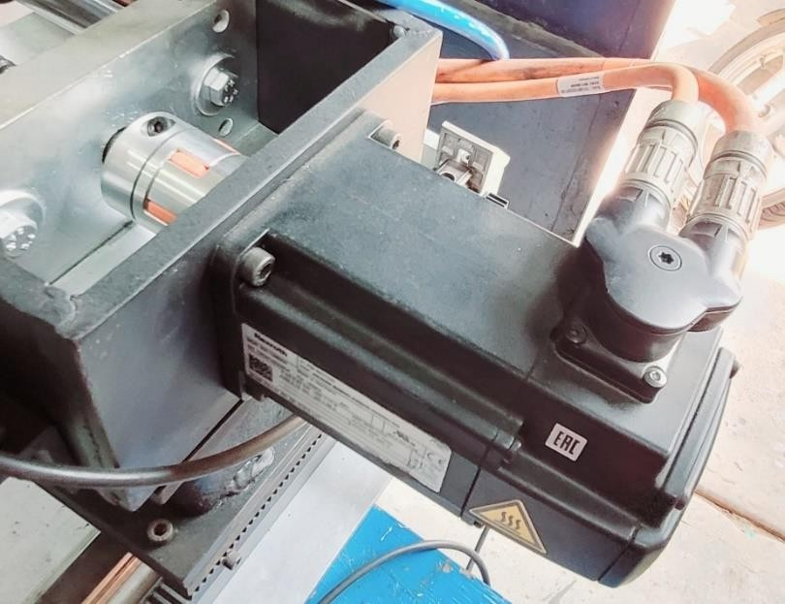
Figure 11. Servo Motor

A servo motor is an electrical device that is used to control the position, speed, and acceleration of a mechanical system. They are used in a wide range of applications such as robotics, industrial automation, aerospace, and many more. Servo motors are designed to provide precise and accurate control over the movement of a system, making them an ideal choice for applications that require high levels of accuracy and control.

Servo motors work on the principle of closed-loop control. The position sensor sends feedback to the control electronics, which then adjust the motor's position until it reaches the desired position. The control electronics also adjust the motor's speed and acceleration to ensure smooth movement.

Servo motors are designed to provide high levels of accuracy and precision. They are capable of achieving very precise and repeatable movements, making them

ideal for applications that require accurate control over position, speed, and acceleration. Servo motors are capable of producing high levels of torque, which makes them ideal for applications that require high levels of power. The torque output of a servo motor is dependent on its size and design. Servo motors are capable of achieving high speeds, making them ideal for applications that require fast and precise movements. Servo motors are controlled using a signal that is typically in the form of a pulse-width modulation (PWM) signal. The control electronics use this signal to adjust the motor's position, speed, and acceleration.

In conclusion, servo motors are a versatile and powerful type of motor that are widely used in many different applications. They provide precise and accurate control over the movement of a system, making them ideal for applications that require high levels of accuracy and control. When choosing a servo motor, it is important to consider its features and characteristics to ensure that it is suitable for your specific application.

SOLENOID VALVE

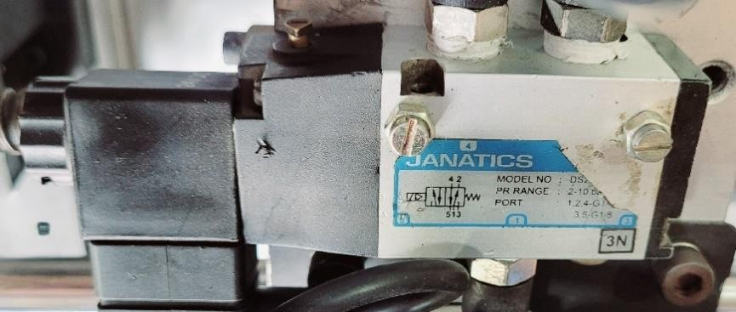
Figure 12. Solenoid Valve

A solenoid valve is a type of electro-mechanical device used to control the flow of fluids or gases. It consists of a solenoid coil, which when energized, creates a

magnetic field that opens or closes a valve. Solenoid valves are commonly used in various applications such as fluid control systems, irrigation systems, and pneumatic systems.

The basic structure of a solenoid valve includes a valve body, a solenoid coil, a plunger, and a spring. The valve body contains the inlet and outlet ports, which are connected to the fluid or gas supply. The solenoid coil is wound around the plunger, which is made of ferromagnetic material. The plunger moves inside the valve body to control the flow of fluid or gas.

When the solenoid coil is energized, it creates a magnetic field that attracts the plunger, causing it to move and open the valve. When the coil is de-energized, the spring pushes the plunger back to its original position, closing the valve.

Solenoid valves are used in a wide range of industries, including automotive, aerospace, food processing, and medical equipment. They offer advantages such as fast response time, low power consumption, and precise control. However, solenoid valves can be prone to failure due to factors such as wear and tear, dirt or debris in the valve, and electrical problems. Proper maintenance and periodic cleaning can help extend the life of a solenoid valve.

PNEUMATIC GRIPPER

A pneumatic gripper is a type of gripping device that uses compressed air to operate. It is commonly used in industrial automation applications to grip and hold objects or components. Pneumatic grippers are typically made up of two or

more fingers that open and close to grip an object, and a pneumatic actuator that controls the movement of the fingers.

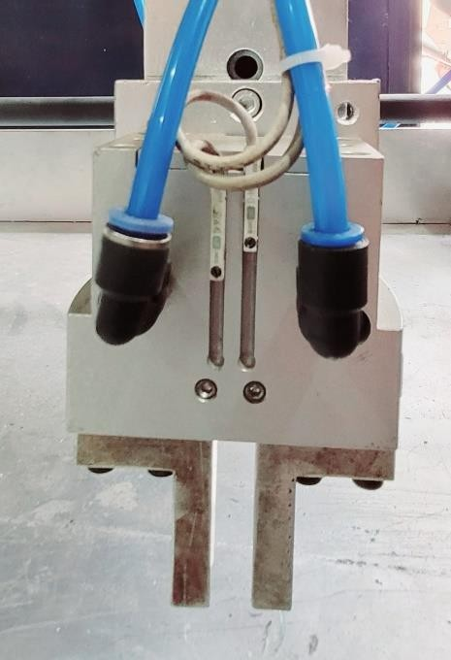
Figure 13. Pneumatic Gripper

Pneumatic grippers are preferred in industrial applications due to their ability to provide strong gripping force, high speed, and accurate positioning. They are also relatively low-cost compared to other types of gripping devices, making them a popular choice in many manufacturing processes.

Pneumatic grippers can be controlled using a variety of methods, including manual control valves, electric solenoid valves, or programmable logic controllers (PLCs). The choice of control method depends on the specific application and the level of automation required.
Some of the key benefits of pneumatic grippers include their ability to handle a wide range of objects, their durability, and their ease of maintenance. They are

also highly customizable, with a variety of finger shapes and sizes available to accommodate different object shapes and sizes.

FLOW REGULATION VALVE

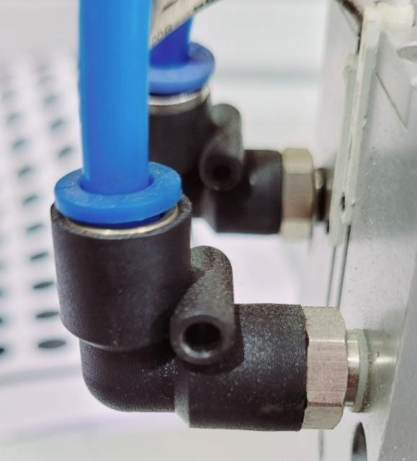
Figure 14. Flow Regulation Valve

A flow regulation valve is a type of valve used to control the rate of fluid flow in a pipeline or process system. It is also commonly known as a flow control valve or throttling valve. The valve operates by altering the effective cross-sectional area through which the fluid flows, thereby changing the flow rate of the fluid.

The working principle of a flow regulation valve is relatively simple. It typically consists of a moveable disc or plug that can be adjusted to vary the flow area of the valve. When the valve is fully open, the flow area is maximized, allowing the fluid to flow freely through the valve with minimal resistance. When the valve is partially closed, the flow area is reduced, causing the fluid to encounter greater resistance, and reducing the flow rate.

The position of the valve disc or plug is controlled by an actuator, which can be either manual or automatic. In manual valves, the actuator is typically a handwheel or lever that is manually operated by an operator. In automatic valves, the actuator is usually an electric, pneumatic, or hydraulic device that responds to a control signal from a process control system.

The flow rate through the valve is typically determined by the position of the valve disc or plug. As the disc or plug is moved towards the closed position, the flow area is reduced, and the resistance to flow increases, resulting in a lower flow rate. Conversely, as the disc or plug is moved towards the open position, the flow area is increased, and the resistance to flow decreases, resulting in a higher flow rate.

Flow regulation valves are used in a wide variety of applications, including water and wastewater treatment, chemical processing, oil and gas production, and power generation. They are available in a range of sizes and materials, depending on the specific application requirements.

REED SWITCH

A read switch, also known as a reed switch, is an electrical switch that is activated by the presence of a magnetic field. It consists of two ferromagnetic metal reeds inside a glass or plastic envelope, which are separated by a small gap. When a magnet is brought close to the switch, the magnetic field causes the reeds to attract each other and close the gap, completing an electrical circuit.



Figure 15. Reed Switch

Read switches are commonly used in a variety of electronic and electrical devices where a non-contact switch is required. For example, they are used in burglar alarm systems to detect the opening of doors and windows, in automatic doors to sense the presence of people, and in industrial applications to detect the position of moving parts.

One advantage of read switches is that they are simple and reliable, with no moving parts to wear out or get stuck. They also have a long-life expectancy and can operate in harsh environments with high humidity or temperature fluctuations.
Read switches come in a variety of sizes and shapes, with different electrical ratings and sensitivity to magnetic fields. They can be normally open or normally closed, and can be activated by either a magnet or a magnetic field generated by a coil or solenoid.

LIMIT SWITCH
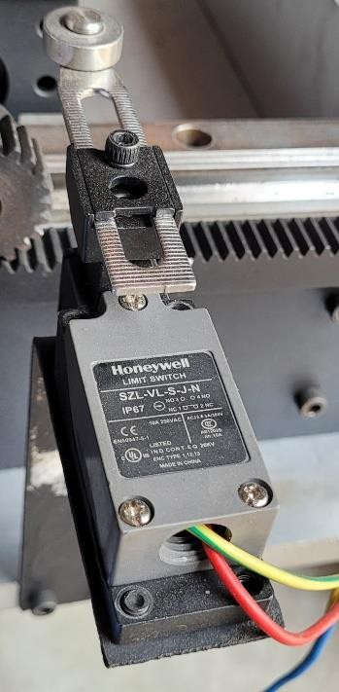
Figure 16. Limit Switch

A limit switch is a type of switch that is commonly used in industrial applications to detect the presence or absence of an object, or to determine the position of a moving part. It is designed to act as a mechanical trigger, which activates or deactivates a circuit when the switch is moved beyond a certain position or limit.

The basic construction of a limit switch consists of a mechanical actuator, which is typically a lever arm or a plunger, and an electrical switch mechanism that is activated when the actuator is moved beyond a certain point. The switch mechanism may be either a mechanical switch or a proximity sensor, depending on the specific application and the type of switch being used.

Limit switches are used in a wide variety of applications, including machine tools, conveyor systems, packaging equipment, and other industrial machinery. They

are typically used to control the movement of a machine or a process, or to provide feedback to a control system.

One of the primary advantages of limit switches is their versatility. They can be used in a wide variety of applications, and are available in a range of sizes, styles, and configurations to suit different needs. They are also relatively simple and easy to install, and require very little maintenance.

However, there are some limitations to using limit switches. They are generally not suitable for high-speed applications, as the mechanical actuator may not be able to keep up with the speed of the moving object. In addition, they can be prone to wear and tear over time, especially if they are used in harsh or dirty environments.

PNEUMATIC CYLINDER

A pneumatic cylinder is a mechanical device that is used to generate force and motion through the use of compressed air. It consists of a piston, a cylinder, and a valve or port. The cylinder is typically made of metal and contains a moving piston that is driven by the force of compressed air.

Pneumatic cylinders are commonly used in a variety of applications, such as manufacturing, construction, and transportation. They are used to lift heavy loads, move materials along conveyor belts, and actuate valves and other mechanical components.

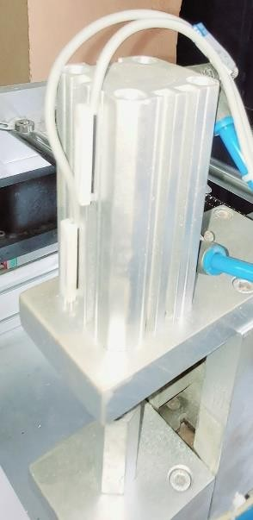

Figure 17. Pneumatic Cylinder

The operation of a pneumatic cylinder is relatively simple. When compressed air is introduced into the cylinder, it enters the chamber behind the piston, causing the piston to move forward. This movement can be used to push or pull a load, or to actuate a mechanical component. (Used in the Project) Double-acting cylinders: These cylinders can generate force in both directions, as compressed air is used to move the piston back and forth.

In conclusion, pneumatic cylinders are an essential component in many industrial and mechanical applications, providing a simple and efficient means of generating force and motion through the use of compressed air.

SERVO MOTOR GEAR BOX

Servo motor gears are designed to provide precise and accurate motion control by converting the rotational output of the motor into linear or angular motion. They are often used in robotics, CNC machines, and other applications that require high precision and accuracy.

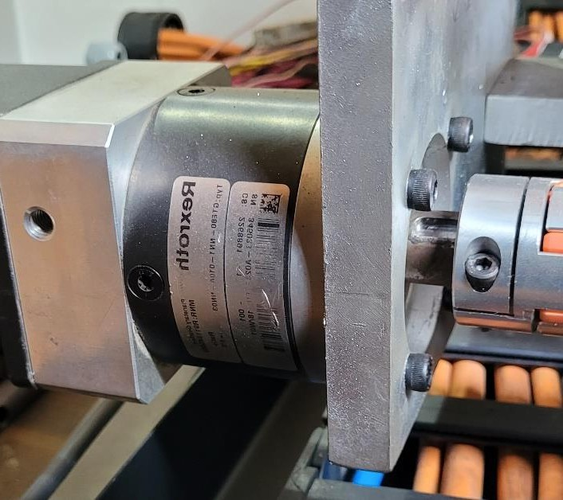
Figure 18. Servo Motor Gear Box

There are several types of servo motor gears, including spur gears, helical gears, bevel gears, and worm gears. Each type has its own advantages and disadvantages, depending on the specific application and requirements.

(Used in the Project) Spur gears are the simplest and most common type of gear, consisting of straight teeth that are parallel to the gear axis. They are used for low-speed applications and are not suitable for high-speed or high-torque applications.

Overall, the selection of a servo motor gear depends on the specific application and requirements, including speed, torque, accuracy, and load capacity.

LINEAR MOTION GUIDE RAIL
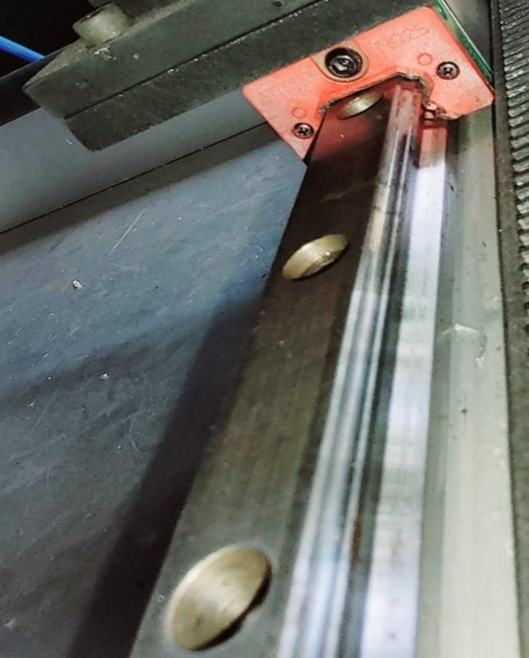
Figure 19. Linear Motion Guide Rail and Block

Linear motion guided rails are mechanical components that provide linear motion guidance and support to moving components in a wide range of industrial applications. They are also known as linear guides, linear bearings, or linear slides.

These devices are typically used in applications where precise linear motion is required, such as in CNC machines, robotic arms, and other automated manufacturing systems.

The linear motion guided rail consists of two main components: a rail and a carriage. The rail is a long, straight piece of metal or other material that provides a precise path for the carriage to travel along. The carriage is a platform that is attached to the moving component and travels along the rail. The carriage typically contains a set of rollers or ball bearings that roll along the surface of the rail, providing smooth and precise linear motion.

Linear motion guided rails offer several benefits over other types of motion guidance systems. They provide high precision and accuracy, as well as smooth and quiet operation. They also offer high load capacity and are suitable for use in harsh environments. Additionally, they require minimal maintenance and have a long service life.

RACK AND PINION

Rack and pinion are a mechanism used for converting rotational motion into linear motion. It consists of a gear (pinion) that engages with a straight bar (rack) to generate linear motion. This mechanism is commonly used in a variety of applications, including steering systems in automobiles, robotics, and industrial machinery.

The rack and pinion mechanism is composed of two main parts: the pinion and the rack. The pinion is a small gear with teeth on its surface, while the rack is a straight bar with teeth along its length. The teeth of the pinion mesh with the teeth of the rack to generate linear motion when the pinion is rotated.

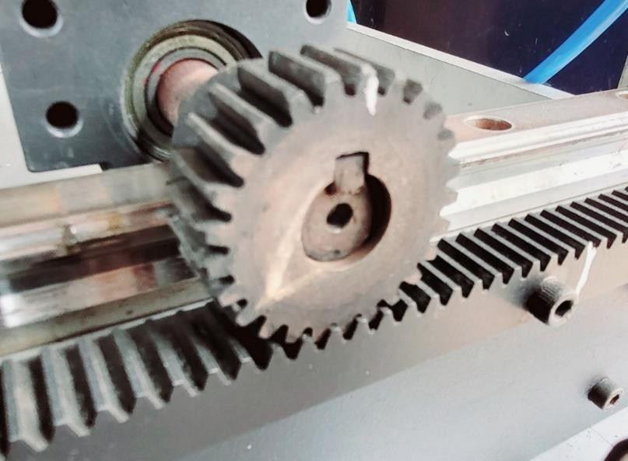

Figure 20. Rack and Pinion

Rack and pinion mechanisms can be made from a variety of materials, including steel, brass, and plastic. The teeth on the rack and pinion must be carefully designed to ensure smooth operation and to prevent excessive wear over time. Lubrication is often used to reduce friction and prolong the life of the mechanism.

In summary, the rack and pinion mechanism are a simple and effective way of converting rotational motion into linear motion. It is widely used in steering systems, robotics, and other applications where precise control and compact size are important.

BALL SCREW ROD

A ball screw rod is a mechanical component used to convert rotational motion into linear motion. It is a type of screw-based mechanism that uses a ball bearing to reduce friction and increase efficiency in transferring power.

The ball screw rod consists of a threaded rod or shaft and a nut assembly. The shaft has a helical groove or thread that is cut into its surface, while the nut assembly contains a number of ball bearings that roll along the thread. The ball bearings are retained within the nut assembly, which typically has a recirculating system to keep them moving through the thread as the nut moves along the shaft.


Figure 21. Ball Screw Rod

When rotational force is applied to the shaft, the ball bearings roll along the thread, causing the nut to move along the shaft in a linear direction. This creates a precise and efficient means of converting rotational motion into linear motion, making ball screw rods ideal for use in many industrial and commercial applications.
Ball screw rods are known for their high accuracy, repeatability, and efficiency, making them well-suited for use in CNC machines, robotics, aerospace, and medical equipment. They are also capable of handling heavy loads and high speeds, making them a reliable and efficient choice for a wide range of applications.

CHAPTER 5
WIRING DETAILS
  - AC Section
The power supply is given from 3 faze 415 Volts with Neutral. The 3-phase wire is Red (positive) Yellow (Neutral) Blue (negative). For the 2 phase 24 v supply Brown (positive), Blue (Negative)The 3 Phase EB power supply Is connected to the RYB connectors. The RYB Connectors is connected to the Rotary switch. The rotary Switch when powered on the MCB activates with 3 poles each, the MCB is connected to the input of the Contactors. The contactors contain 18 amps. The MCB used here is a 3 Schneider, 1LXT. The Contactor to Servo drive connection is done by Output to the servo drive input. The Black for the Servo drive is Neutral wire. The Black Contactor is connected 2 poles MCB neutral.

NEUTRAL CONNECTION
The Red Single phase is connected to the 2 pole MCB connected to R phase of the 3rd MCB of the Top first pole. The power box with 230 V is supplied to the A1 of the main contractor. The Neutral is connected A2 of the contactor. The R phase of the supply is connected to the SMPS to the Relay. The Neutral is connected to the Contactors for the A2, the Relay with the P1, P2, and P3 are the common with 230 V supply The O1, O2, O3 is connected to the A1 of the Contactors.

DC SECTION
The SMPS receives the AC power supply and converts it the DC power supply. It has four terminals two negative and two positive supplies. The negative and positive pair is connected to the Terminal 4 Block of fuse and the Vision

camera in the field. The other pair is connected to the Fuse terminal block. The first TB is connected to the 4-fuse block to the servo drive X31 and the second TB is connected to the second Servo drive X31 The 4-fuse block connected is connected to the PLC and the Servo Drive.

PLC CONNECTION
The PLC connection of output with 8 ports is connected to the Relay with Terminal Block. The input with 8 ports with first 2 ports connected to X47 of drive and the rest to the Terminal block.

DIRECT ONLINE STARTER
The DOL Starter is connected to the relay with connector and is each of the poles connected to stop push button and second pole connected to the 13 NO and 14 NOS as Neutral the green with Start push button.

HMI CONNECTION
The HMI is connected with the indicator with the power supply from the SMPS through the Terminal Block.

CIRCUIT DIAGRAMS

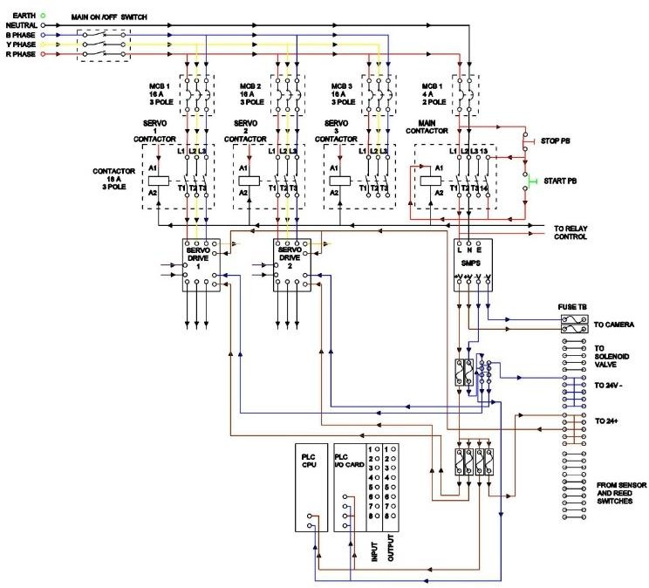

Figure 22. Circuit Diagram

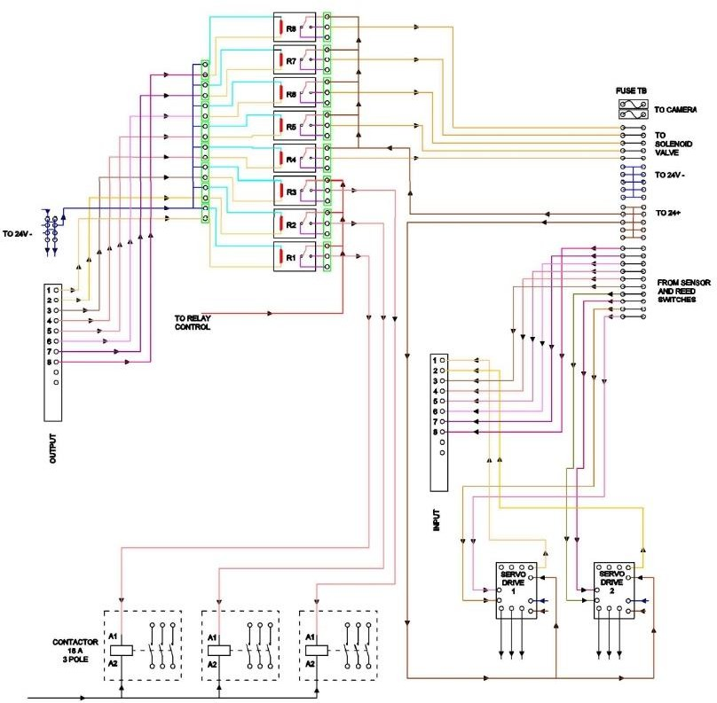

Figure 23. Circuit diagram

CHAPTER 6
METHODOLOGY
6.1. WORKFLOW MODEL

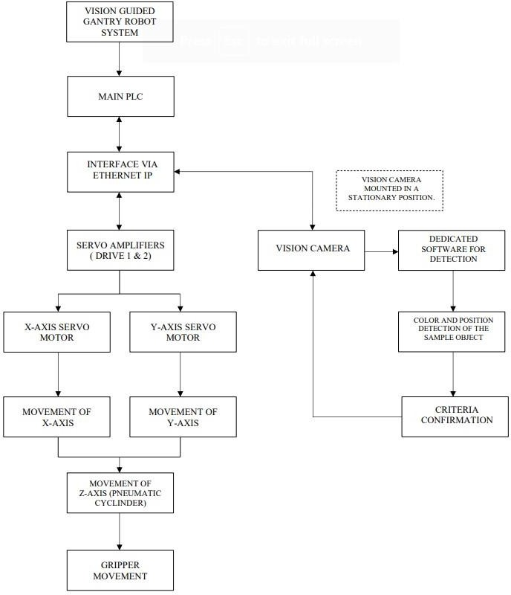

Figure 24. Methodology

CHAPTER 7
WORKING

The electrical system of this gantry robot consists of a primary input of 3 phase 415 V and Neutral, which is received from the EB power supply. The power supply then goes through a Rotary switch, which is the primary No/Nc contact of the system. Without the Rotary switch, the system cannot function properly. The Rotary switch is connected to the input of the MCB circuits, which is then connected to the Contactors. The output of the MCB with 3 phase 415 V is connected to Contactors that supply power to the servo drive with the help of SMPS.

The SMPS plays a crucial role in the system, converting the AC voltage to 24V DC voltage, which is then supplied through the relays for the Servo drive after the Contactor sends power to the Servo Drive. The SMPS sends DC output to the Servo drive to Servo motors. In between, the PLC gives the command to the Servo drive for performance from the SMPS. Every component in the electrical part has safety fuses to prevent short circuits or overload.

The Vision Camera is connected to the terminal inputs of the PLC, which is used for object detecting in the Plate under the X axis gear. The Vision camera provides readings for the location of the object and the area limitation that can be covered by the robot. The Servo drive performs the movement of the 3-axis robot with the commands of the PLC. The PLC is installed with a program for the performance of the task and indications that need to be shown in the HMI of the system.

The gantry system moves in three orthogonal axes according to the Cartesian coordinates, defined as X, Y, and Z. Each axis is arranged at a right angle, allowing three degrees of motion. The gantry is further characterized by supporting at either end. In the Y axis, a rotational gear with a Servo motor is fixed laterally to the Aluminium Profile elevated above the X axis, located on both sides of the robot. For the movement of this Y axis, a Servo motor is used on the rotating end of the rod with movable gear. The X-axis mounting plate (Sub- assembly) is used to move along the 20*20 Aluminium Profile driven by using a Servo motor, which moves along the X axis of the gantry robot.

The gear in the X axis maintains the same. Over this Y axis Sub Assembly, the Z- axis is mounted in the centre of the Y-axis plate and driven by a Servo motor, which is fitted on the other side (front side) of the Z-Axis. At the end of the aluminium profile (bottom), a Pneumatic gripper holds the picking objects using a Pneumatic Compressor system with Vision camera over each other. The robot consists of 2 Servo motors. The 2 Servo motors are used to control the Y-axis direction and X-axis direction. For the controlling of all these three-axis motors and a vacuum gripper, a python-based control software is used and programmed according to the task to be performed.

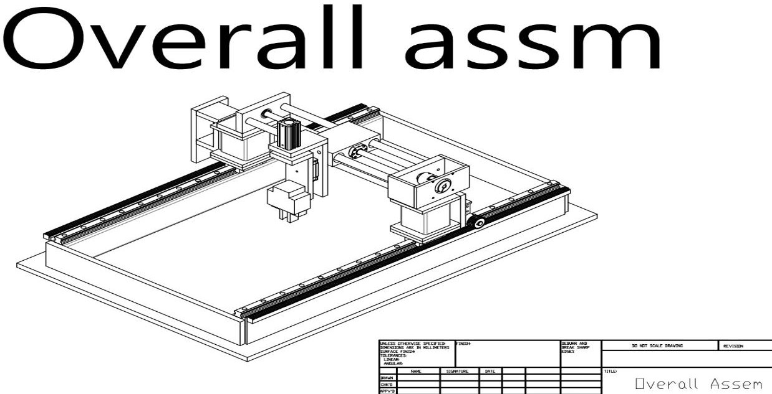
43

Figure 25. Overall assembly of the Gantry System

CHAPTER 8
OUTPUT AND RESULT OUTPUT
Vision camera detects the object inside an allocated location. The camera sends the detected data to the PLC which receives the data as information through the input module. From the input module it gives the command to the X Axis and Y Axis.
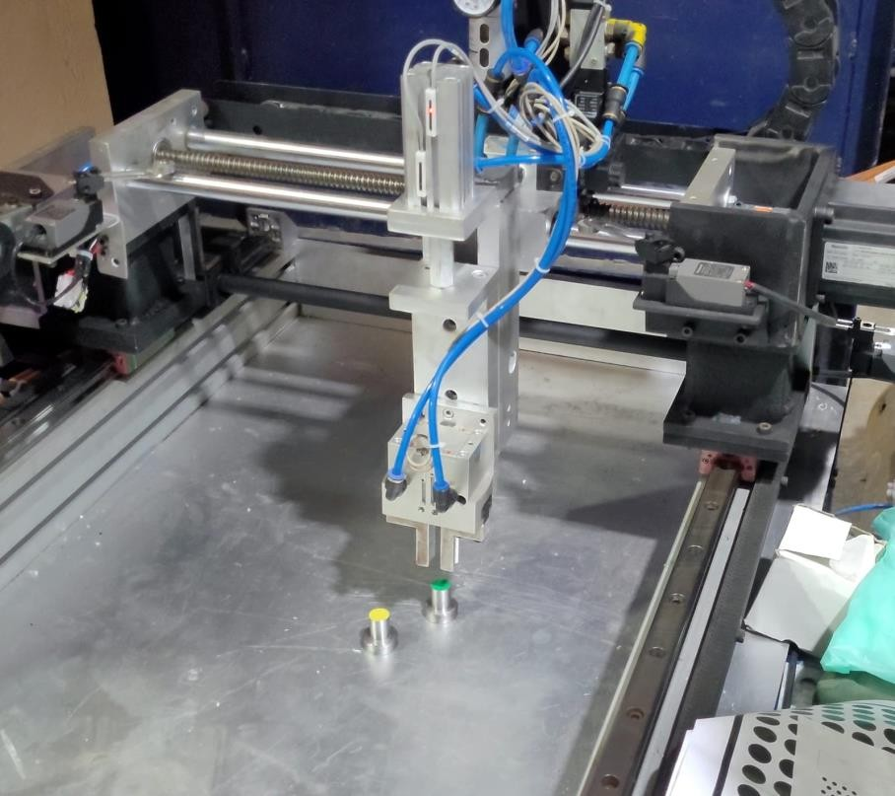

Figure 26. To the first pick up position

The X axis consisting of a Servo motor connected to the LM rail and rack & pinon of the Aluminium profile. The Servo motor is connected to a Servo drive which is connected to the PLC. The servo drive gives the command signal of the movement of the X axis of the Servo motor to move the X Axis to the desired position.

The Y axis is connected with a Servo motor, the motor is connected to the ball screw connection of the Aluminium profile in which on rotation over the motor the gear starts to move for seeking the correct position of the object.

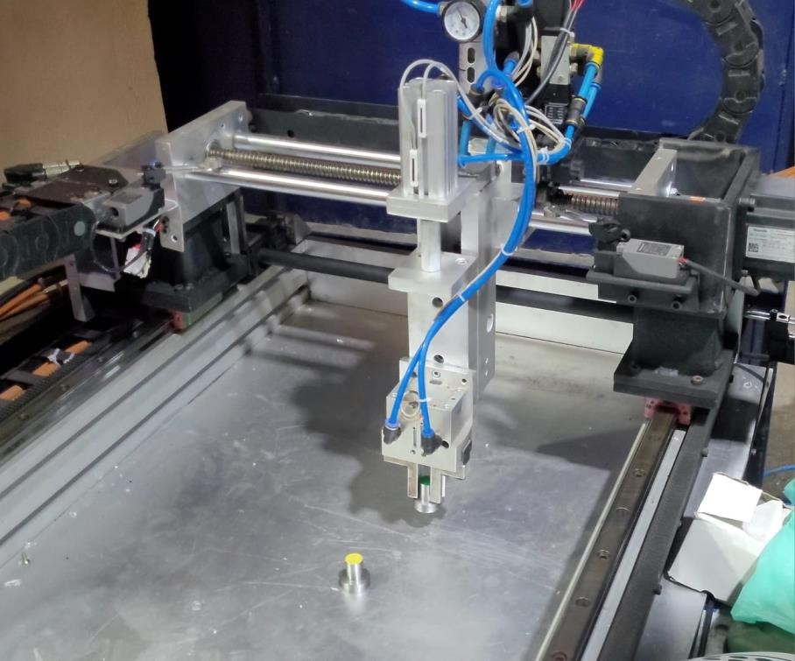

Figure 27. Movement of the gantry (First job picked up)

By the pneumatic cylinder the Pneumatic gripper comes down and clamps the object. After picking the object the robot moves to the desired area by the data from the PLC and moves to the position and also brings the object to the desired marked location.

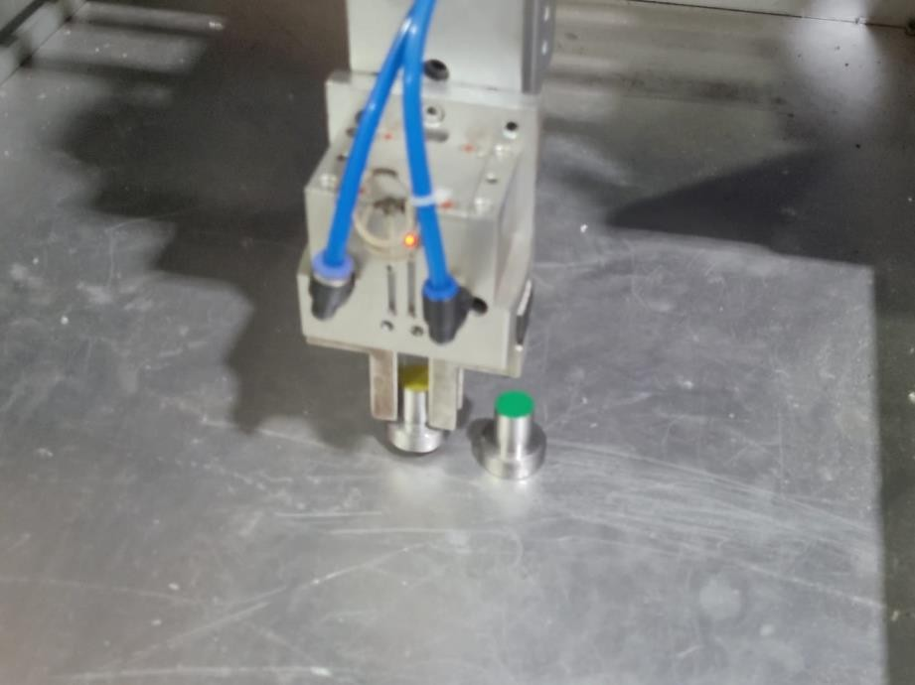

Figure 28. Placing of second target

RESULT

The Vision camera is used to detect the object and its position on the base plate, while the pneumatic Z-axis actuator is used to pick up the object using a pneumatic cylinder and solenoid valve.

Once the object is picked up, the X and Y-axis actuators move the manipulator along the area where the object was detected, allowing it to be positioned and placed in the desired location. This process can be repeated for multiple objects and positions, depending on the specific application and requirements of the system and the objects are sorted/segregated.

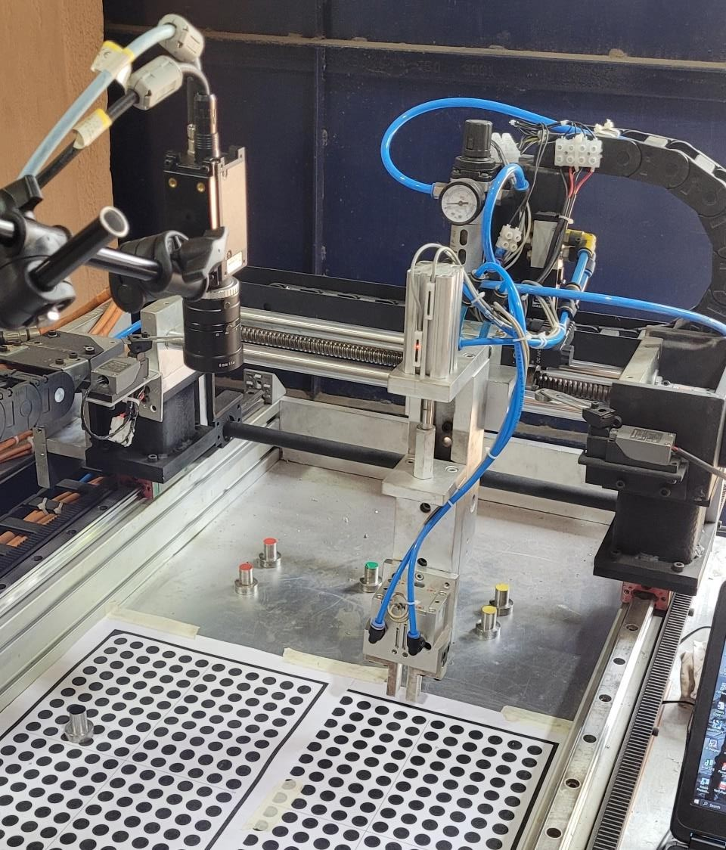

Figure 29. Machine at rest

Overall, the use of a Vision camera and pneumatic actuators can provide a highly efficient and precise method for picking and placing objects in automated manufacturing or assembly processes.

CHAPTER 9
CONCLUSION

In conclusion, the pick and place gantry robot project using a vision-guided camera has demonstrated the potential of combining machine vision with gantry robotics in industrial automation. The project involved designing and building a gantry robot that could pick up and place objects using data from a vision-guided camera.

The project has highlighted the importance of vision-guided systems in increasing the precision and accuracy of gantry robots. The use of image processing algorithms and machine learning techniques was critical in enabling the robot to detect and identify objects and navigate through the workspace.

The integration of a vision-guided system also proved essential in enabling the robot to adapt to changes in the environment and handle objects of different shapes and sizes. The use of sensors and feedback mechanisms ensured that the robot could operate efficiently and avoid collisions or errors.

Overall, the project has demonstrated the potential of using vision-guided systems in enhancing the capabilities of gantry robots in industrial automation. The pick and place gantry robot with a vision-guided camera can significantly increase productivity and reduce manual labour, making it a valuable asset in manufacturing and other industries.

FUTURE SCOPE

One of the most promising future scopes for gantry robots with 3D cameras is in the field of quality control and inspection. With their advanced imaging capabilities, these robots can quickly and accurately detect defects, measure dimensions, and identify surface irregularities, thereby ensuring that products meet strict quality standards. This can help manufacturers reduce waste, improve yields, and enhance customer satisfaction.

Another area where gantry robots with 3D cameras can make a significant impact is in the assembly of large and complex structures. With their larger working areas, these robots can handle bulky and heavy components with ease, while their 3D cameras can provide real-time feedback on the positioning and alignment of parts. This can streamline the assembly process, reduce errors, and increase throughput, particularly in industries such as aerospace, automotive, and construction.

machine learning algorithms to enable these robots to learn from past experiences and improve their performance over time. Additionally, advances in materials science and robotics could lead to the development of more lightweight and flexible gantry robots, which could be used in a wider range of applications.

REFERENCE

- “Design and Development of Gantry Robot for Object Validation of Pallets” Jetir (2021) ISSN:2349-5162, Vol.8, Issue 8, ppl: 1-5, Aug-2021[Cross ref] Pavan Kumar K, Keerthi SM, Vishal J Bhat, Jayentha M, LR Jagadeesh.
- “Mobile Gantry Robot for Pick & Place Ap plication”. IEEE (2020), 22-23 Feb-2020[Cross ref] Lokesh P Ch an dak, An iket Junghare, Tejas Naik, Neema Ukani and Saurabh Chakole.
- “Design of pick and place and color sorting system usin g VDI 2221”. IOPScience ,1007, 012165. [Cross Ref] Michael, V Halim and Purna Irawan.
- “Linear Gantry Robot Control System” International Journal o f Scientific Research in Science and Technology. 10.32628/ijsrst2057123;2020; pp. 30-38. Siddhi Date, Shreya Makwana, Divya Mewada Dr. Sheshang, D. Degadwala.
- “Mobile Gantry Robot for Pick & Place Application” 2020 IEEE International Students' Conference on Electrical,Electronics and Computer Science (SCEECS). 10.1109/sceecs48394.2020.171; 2020. Lokesh P Chandak, Aniket Junghare, Tejas Naik , Neem a Ukani, Saurabh Chakole.
- “Design of a Gantry Robot Gripper for Machine To ol ” DOI: 10.3795/ksme- a.2018.42.4.321; Transactions of the Korean Society of Mechanical Engineers A, 2018; Vol 42(4), p p . 3 2 1-329 . Jae Kung Lee, Myung Chul Choi, Gab Soon Kim.
- ”Design and development of the visual guided gantry robot system” 2021 JETIR August 2021, Volume 8, Issue 8,10.32628/ijsrst2057123;2020; pavan kumar, SM keerthi, L jadageesh.

- “The System Design and Evaluation vision-Guided gantry Robot”, 2015 Aug;31(4):1044-1053. doi: 10.1109/TRO.2015.2452776, Max L. Balter,Alvin I.
Chen,Timothy J. Maguire.

- ” A gantry robot automatic positioning system using computational vision”, 11th National Congress on Experimental Mechanics. Porto/Portugal 4-7 November 2018. Ed. J.F. Silva Gomes. INEGI/FEUP (2018); ISBN: 978-989-20-
8771-9; pp. 1031-1042., Beites, Nuno dias, manuel.

- “A Customised Gantry Pick and Place System for Forging Industries”, DOI: 10.1109/ICAECA52838.2021.9675788, Published in: 2021 International Conference on Advancements in Electrical, Electronics, Communication, Computing and Automation (ICAECA), S. Ranganathan,M Saravanabalaji.
- ” vision guided robotic systems with intelligent control” (2022) A Novel Velocity-Based Control in a Sensor Space for Parallel Manipulators. Sensors 22:19, pages 7323.Crossref, V. Kalaichelvi, R. Karthikeyan, ahmed haj Darwish.

